Renju lesson on December 13, 2001
Hello everyone! Welcome to Online Renju Class. Today we will learn the new 5th move. 5-f7. I used to consider this move to be even better than 5-i8. How many of you have played it before. Seems nobody?
Well, here black can become very strong. Lets find out how. 6-g7 is the only interesting move here. Others lose fast. Now, which 7th move is good? Yes, 7-g6 seems natural, but after white’s g10 it becomes complicated. I know you want to learn the simpler way, so we will study 7-g9. Can white try any other move except 7-i7? Well, white must block black pair, but if 8-f10, then the left side will be too open for black.

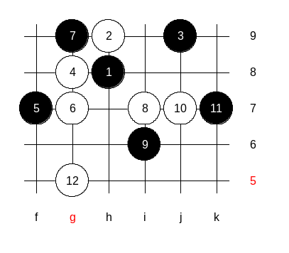
Now, black has an initiative. How can black go on? Any suggestions? Defend or attack? Yes, span is right. We must worry white’s counter-attack at i6. Therefore 9-f10 is impossible. Move 9-f8 is active but too early. Black isn’t ready for powerful attack yet and early activity would cause weakness only. So, as most of you said, and I agree, we will go to 9-i6. I know, Russian top players have some analyses for white defense here. That is why Kozhin and Sinyov dare to play d5 in WC finals. According to their idea, the best white move is 10-j7. And k7 is natural response indeed. In fact, I remember using i8 instead of k7 against Sinyov some years ago, and later got confused and made some weak moves later. But I think i8 was a bad move. It allowed white to take k7 first. We play 11-k7. White must continue actively and try to fill the board. Otherwise black has too much space and can connect sides easily. If white simply blocks k8 now, then the left side is too wide open. Simulating white attack is necessary in order to force black to defend and at the same time fill the board which will take away the necessary space for black’s future attacks. Therefore white plays g5. Note that white is not attacking. White has no chance to win here. It is “filling up” method only.
Please suggest next black move. Lets see whose suggestion matches with the move I am going to introduce next.

Black plays j8 with an intention to take over the tempo and start attacking. Look at the stones pattern in the upper side. Black has too many there. White defense in upper side is hopeless, right? Since white cannot defend, therefore white must……..?
…… attack, of course. White must make an attacking move that controls black’s VCT. Which one is it? Well, moves h6 and i5 are similar, they both control f8 point. Whereas i5 is better because of space principle. Agree? Now, white has lots of active material. And this attack simulation is reaching its goal – black is forced to waste its material to close white’s attack simulation. Moves until 19 are natural. Now, white makes the last step of its tactics – splitting. G6 and i10. This amazing i10 stone splits both side forces and defends both sides at the same time. We all remember how strong was two area tactics for black. And white used to have hard time in choosing defense. But i10 here can stop both areas. Magic move. If we shift i10 stone to further right side, then black can win through f10, e10.
I think, since black cannot win in either side at the moment, its main goal should be to re-unite the sides. Right?
Or, at least we could try this old tactics I told you long ago when we studied d3 opening: use one side material to kill white, and then the other side runs free. I think the connecting tactics may be too hard this time because white “wall” is too high. Therefore, we might consider using the tactics of “sacrificing one area”. Hmm, lets look how to do. Can anyone come up with an idea or concept? Tunnet, which material you suggest to sacrifice? Hard to choose the area – left side looks less powerful but more space, right side is more powerful but space is smaller.
How about simple j11? OK, and white goes k10. Now, we had sacrificed right side. But it wasn’t a big loss. We still have some right side material left to use it in the future for connections through lower side. Now, black L8? It is too straight, and without left side help the attack in right side fails. How about j5, bringing areas closer? What we are doing now is the typical analysis of the positional style. One who can master this can beat anyone. Move j5 was good in the aspect of connecting, but it was also a good defense move, it blocked white pair that used to annoy blacks on the left side. Now, having closed all, we can use “space move” tactics on the left side. We better keep that f-line pair open as long as possible, so that it could support both f5 and f10 fields. We may also consider “adding power” tactics by playing to k6 first. That might give us more force through h3 point. OK, we try this first. K6.
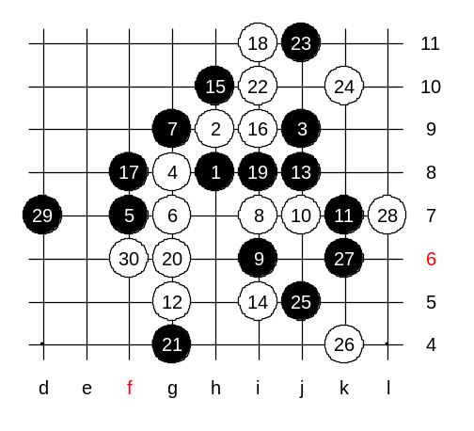
We must play white L7 to avoid killer connection through h3. And now, we got the ”additional force” we wanted – a link to i3. Now, does black have VCT? I also smell VCT here. But remember the basic tactics – don’t go to direct attack if you cannot win. Well, you can all try VCT attack at home. Lets assume VCT is absent and we go on with positional moves. OK? D7 is the best “space move” here, in my opinion. How to continue? Well, I have idea. It is very late, right? So we just finish here. You have already learned all the ideas of positional style and tactics here today. You can try to change or use any sequence of moves. And find the winning idea finally.
We have finished d5 opening. What’s next?

